NAME: MUHAMMAD HUSSAIN

ROLL.NO: 19122010

SEMSTER: 6th

SUBJECT: DATA MINING

SEC: A

RANDOM FOREST MODEL

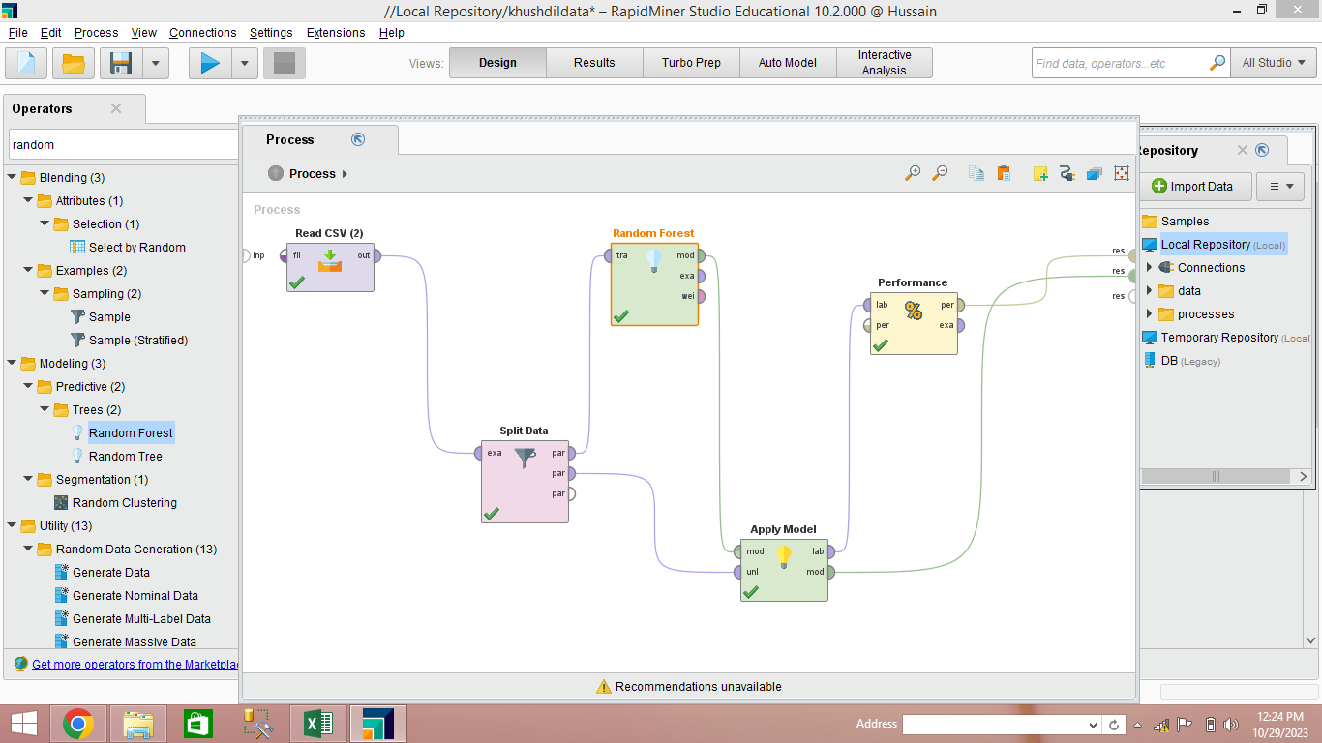

Random Forest Trees

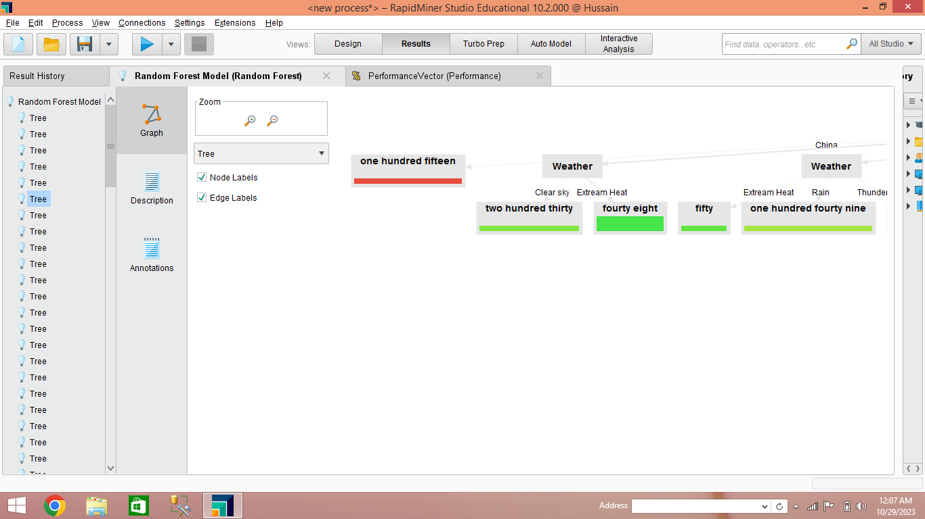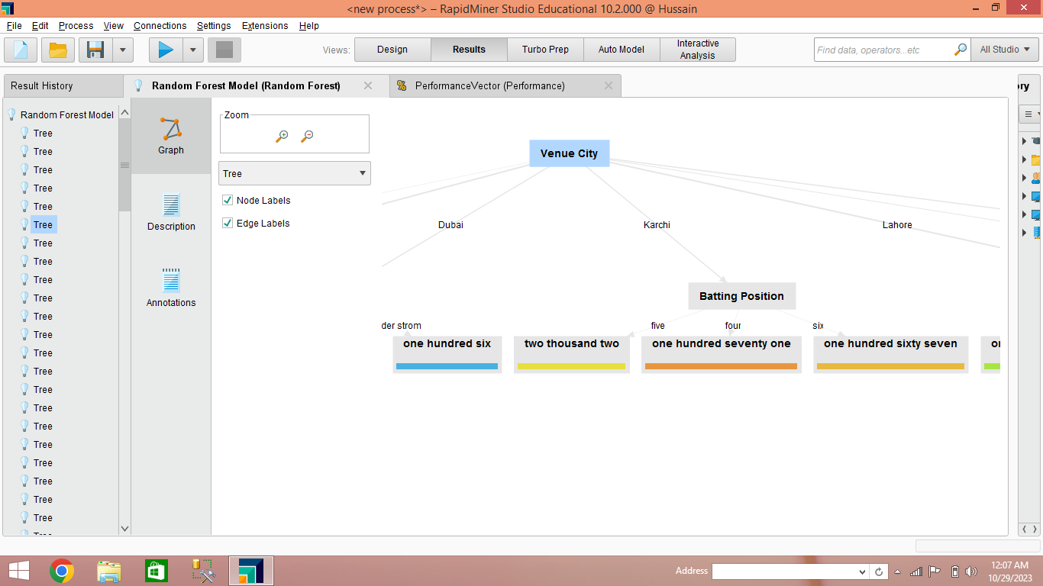

Random Forest Performance Accuracy

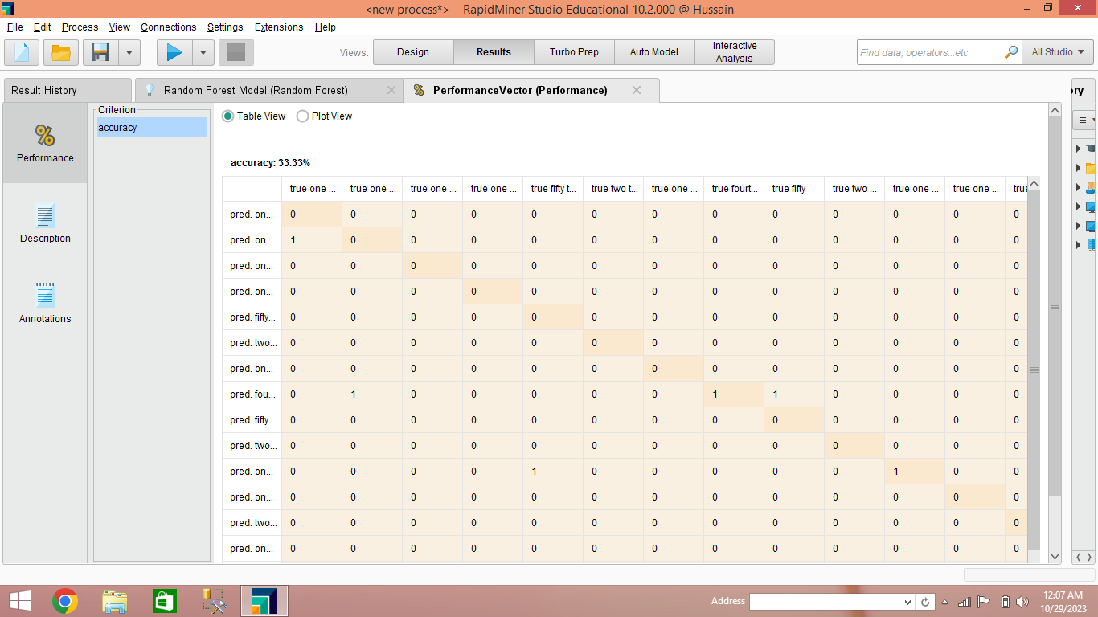

DECISION TREE MODEL:

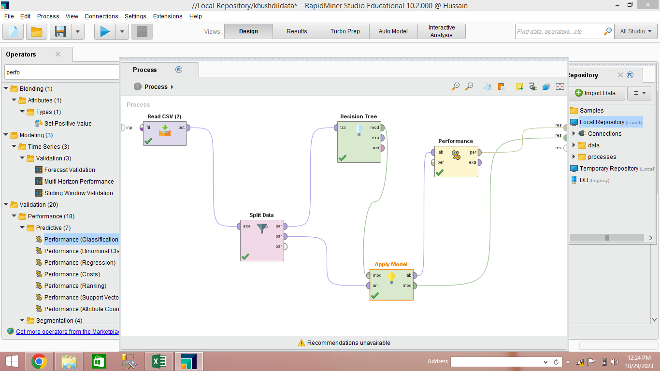

Decision Tree Performance

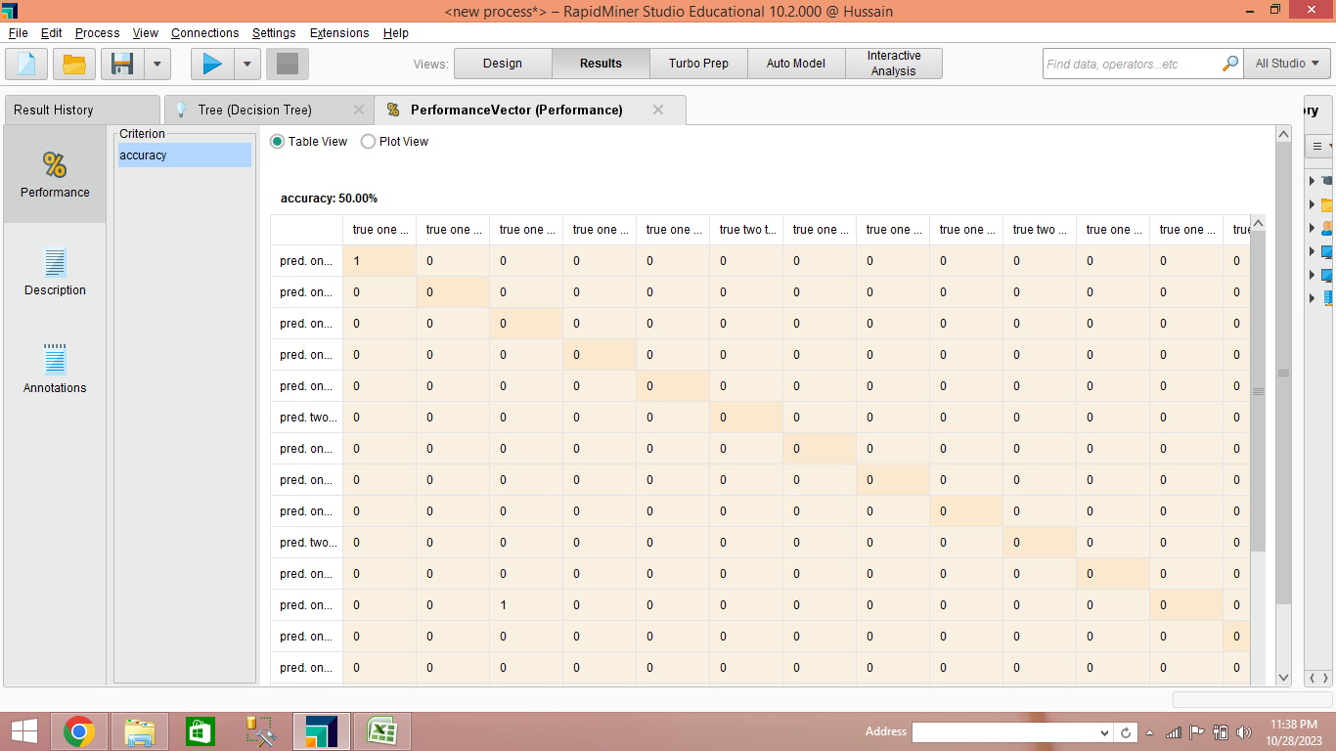

Decision Tree

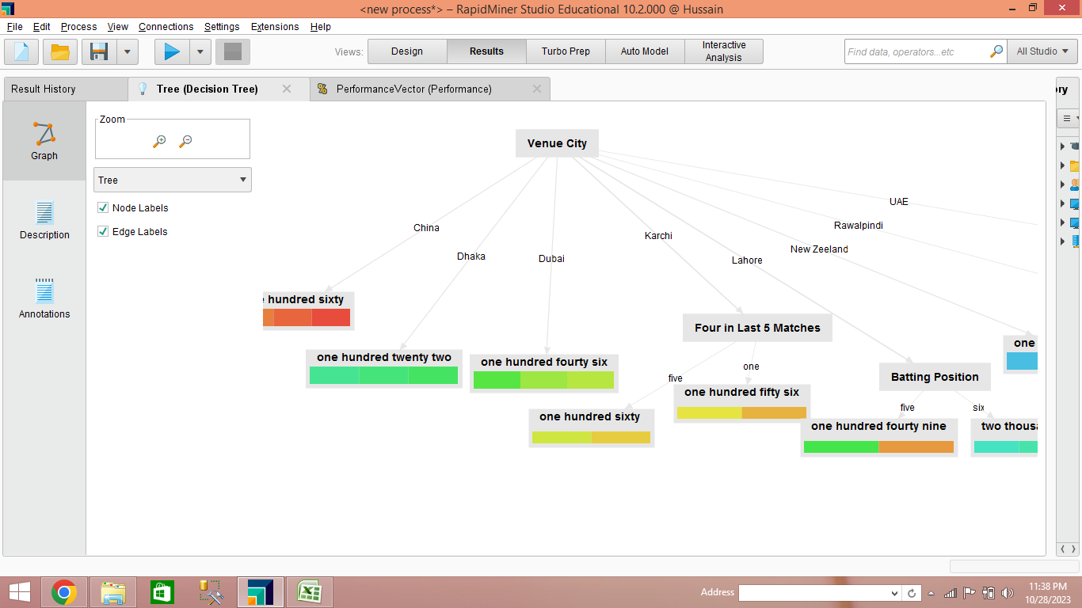

NAÏVE BAYES MODEL

